Institute of Computer Technology

B. Tech Computer Science and Engineering

Subject: BOSS (2CSE204)

**PRACTICAL-EXAM**

**Sahil is working in HR department of Jakarta PVT LTD company. He wants to perform certain operations as per following. Kindly follow it and provide appropriate solution for it. (Make suitable assumptions).**

**1. Create two users EMPLOYEE1 & EMPLOYEE2. Also set passwords for all users. Switch to EMPLOYEE1. Generate public private key pair for EMPLOYEE1. Share public key of EMPLOYEE1 with EMPLOYEE2 and confirm that key sharing is successfully done.**

***SOLUTION***

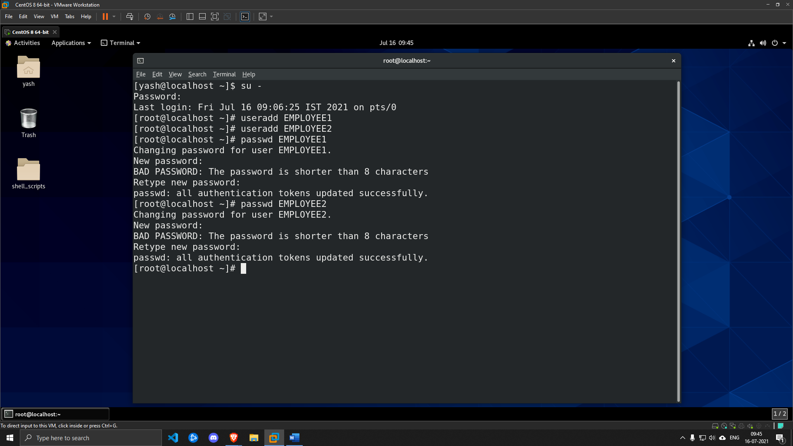

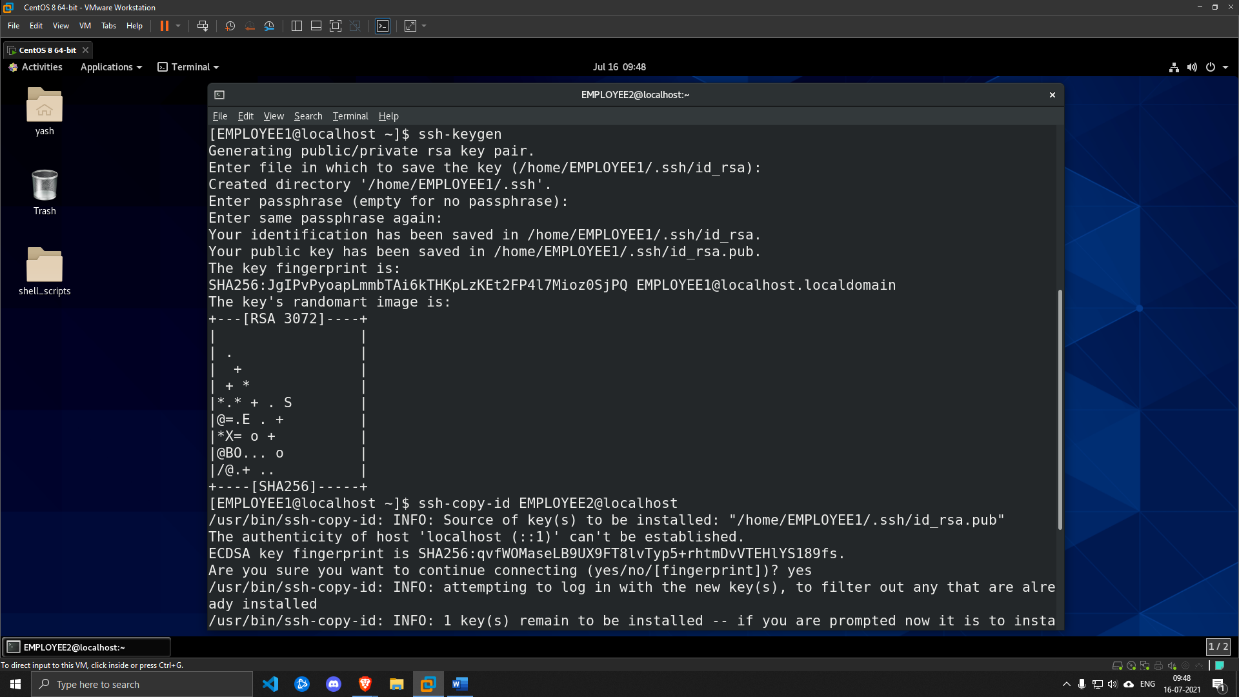

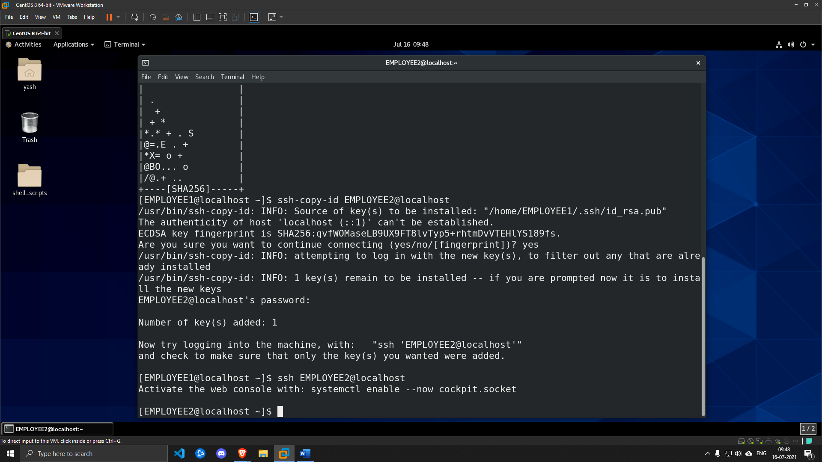

**2. Switch to user EMPLOYEE2 and create five files at home directory of current logged in user with name sky.txt, moon.txt, sunny.txt, solar.txt, sun.txt. He wants to find all the files which file name is having character “n” and store it in to start_n.txt file using shell script.**

***SOLUTION***

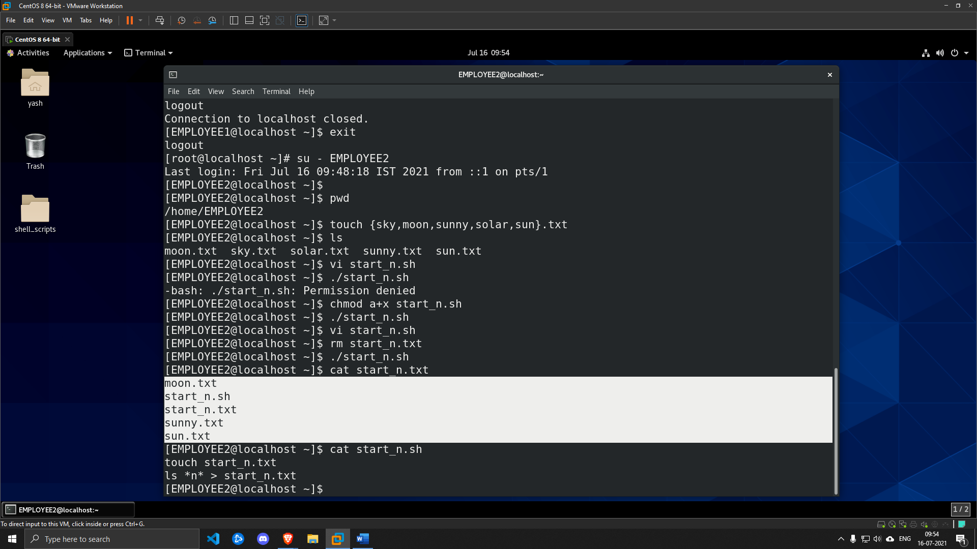

**3. Create new tar file Exam_uni.tar.bz2 and compress all five files.**

***SOLUTION***

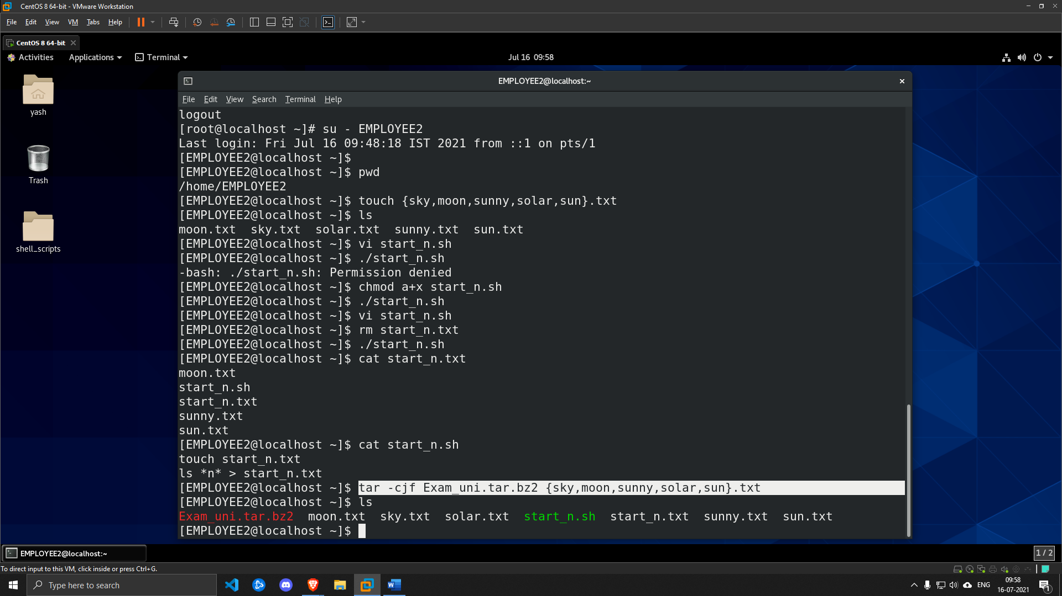

**4. Switch to EMPLOYEE1. Synchronize Exam_uni.tar.bz2 and start_n.txt files from user EMPLOYEE2 to current user. Extract Exam_uni.tar.bz2 at home directory of current user.**

***SOLUTION***

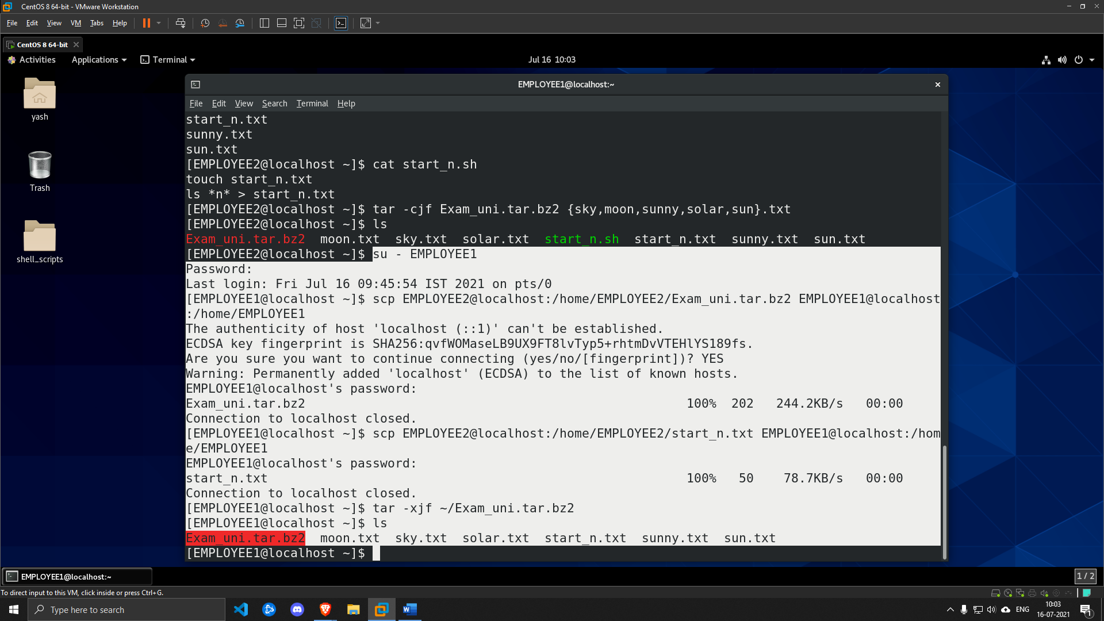

**5. Create five new blank files as file1.txt to file5.txt using single command at home directory of current logged in user. Search all the files using from home directory which are having keyword “o” at any position position using real time search and append output in start_n.txt file.**

***SOLUTION***

